**Lab 2 Assignment**

**Prudhvi Nalluri (16163411)**

**Task:** Generate a text file using sensor tag, which should include 4 types of information and insert the generated data into the Hbase.

**Generating the Data:**

In this I have taken Humidity, Temperature, Time, GPS, Acceleration information into a text file (873.txt) by connecting the nexus device through USB and which is connected to Sensor Tag and the text file is stored into the SD Card of nexus device.

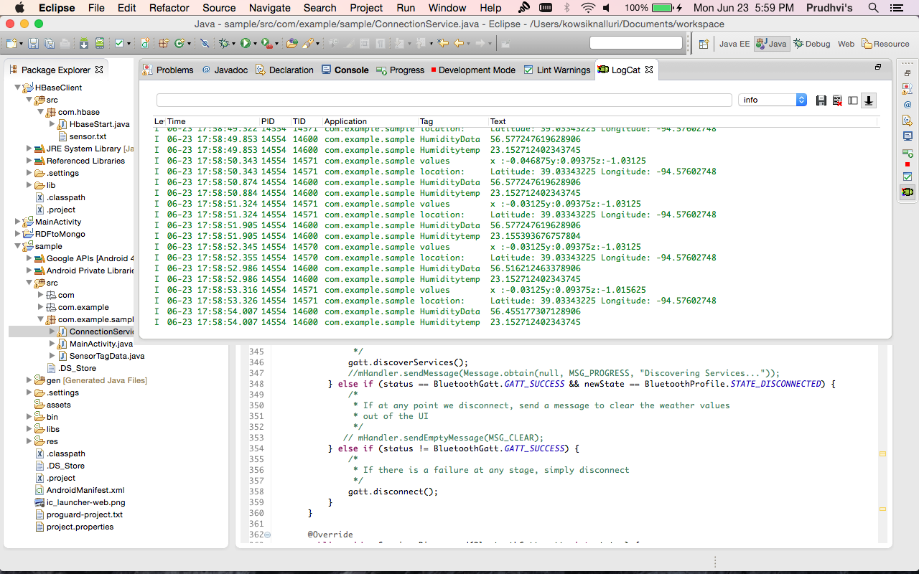

**Creating a Table in Hbase:**

By using HbaseClient Application given, we can create the table “pnnqb” in hbase by opening connection with the hbase client and adding the column family of Humidity and temperature to the table.

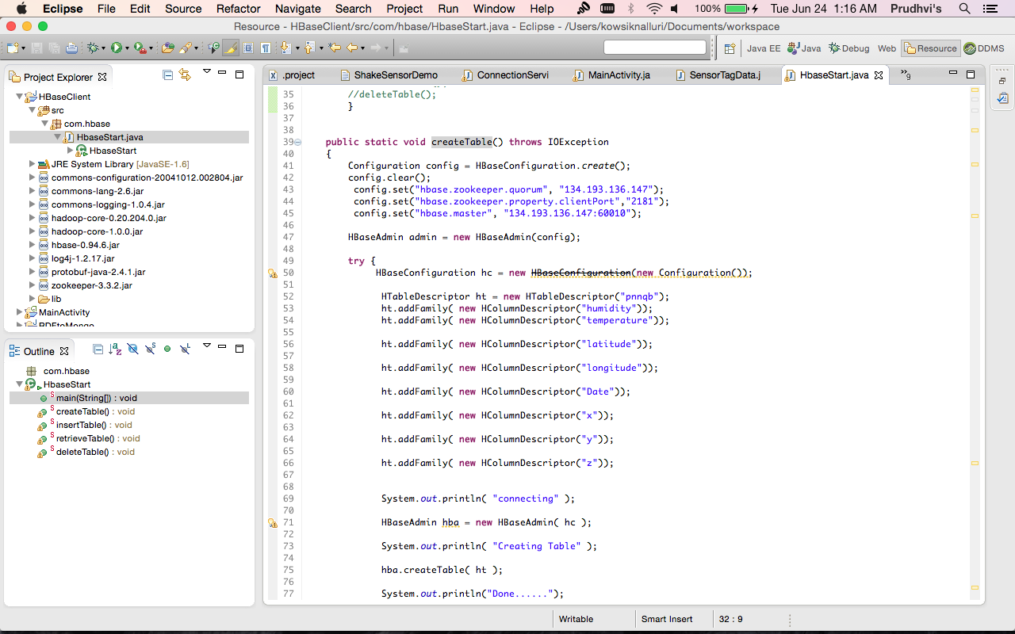

By running the java application I created a table “pnnqb” in the Hbase.

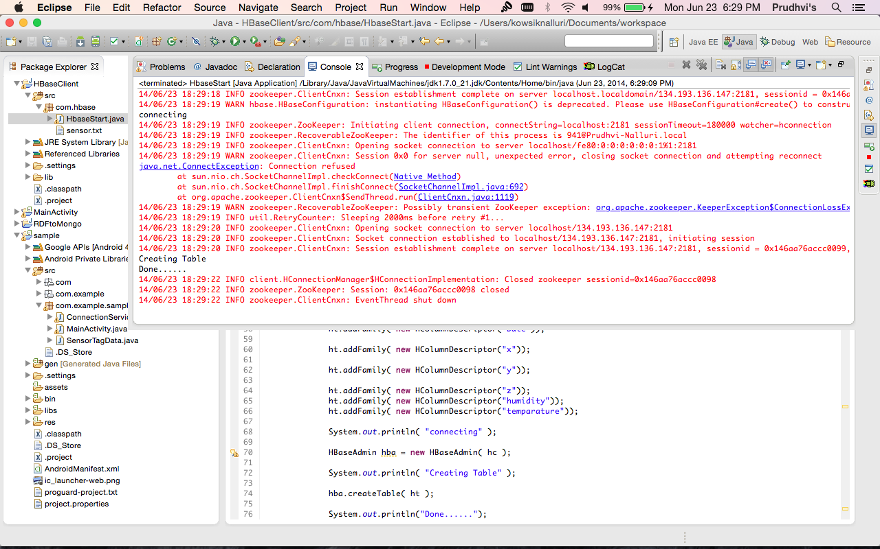

pnnqb table is created in Hbase.

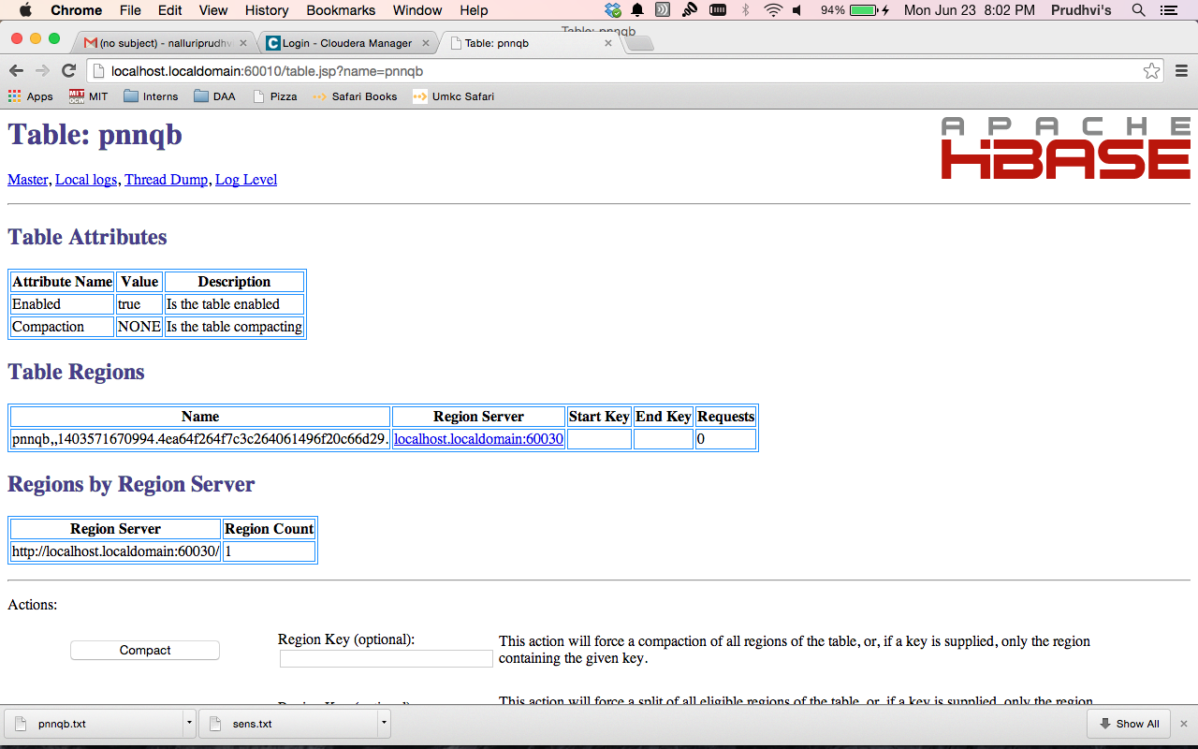

**Inserting Data into Table in Hbase from Text File:**

The table is created, now we have to import the data in the text file (873.txt) into the Hbase, the types of information is seperated by tab space so, we can read the data into the array and open a connection to the Hbase and insert the data into the table we created above “pnnqb” until the text file is empty.

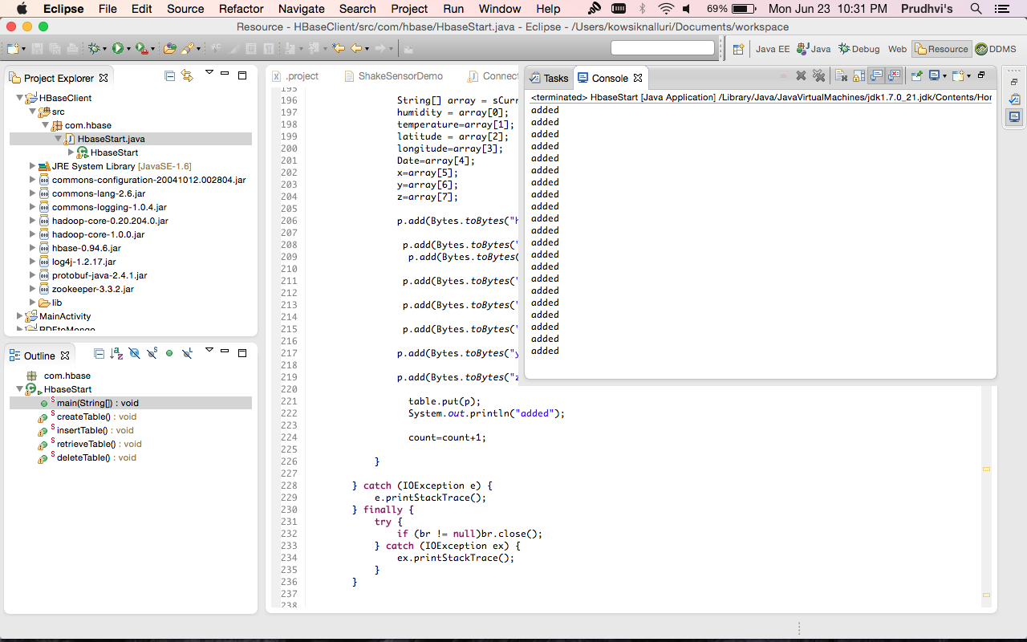

**Retrieving the Data from Hbase:**

Now the data is added into the Hbase “pnnqb” table, now we can retrieve the data by opening the connection to the Hbase

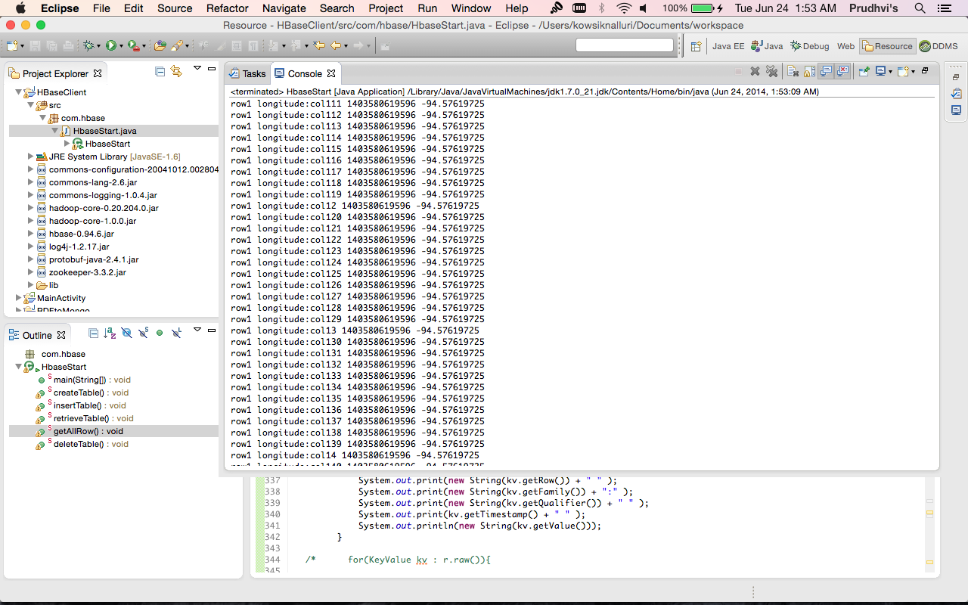

This is the retrieved data from Hbase which we uploaded earlier.